

**Project On**

**CSE-3632**

**Operating Systems Lab**

**Simple CLI and GUI Shell in Python**

**Submitted to —**

**Mohammad Zainal Abedin**

Assistant Professor ,Dept of CSE

**Submitted by—**

**Md. Faisal Hoque Rifat C221076**

**Istahadul Hoque C221059**

**Project Report: SimpleShell CLI and GUI in Pyhton**

***Abstract:***

* This project implements a simple command-line interface (CLI) and graphical user interface (GUI) shell in Python. The shell supports basic commands: ls, pwd, cd, and exit. The purpose of this project is to provide a minimalistic shell environment that demonstrates the integration of core Python functionalities for file system navigation and GUI development.

***Introduction:***

* Shells are an essential part of operating systems, enabling users to interact with the file system and execute commands. In this project, a Python-based shell was implemented to provide basic functionality for navigating the file system. The implementation includes both a CLI for text-based command execution and a GUI for a more user-friendly interaction.
* The commands supported by the shell include:
  + - **ls:** Lists the files and directories in the current working directory.
    - **pwd:** Displays the current working directory.
    - **cd:** Changes the current working directory to a specified path.
    - **exit:** Exits the shell.

***Features:***

* **Basic Shell Implementation**:
  + The project implements a basic shell interface for interacting with the file system.
  + Users can run common file system commands like ls, pwd, cd, and exit.
* **Command-Line Interface (CLI)**:
  + A text-based interface where users type commands directly.
  + Commands like ls, pwd, and cd execute in the context of the current working directory.
* **Graphical User Interface (GUI)**:
  + A simple GUI that provides a user-friendly way to interact with the shell.
  + Commands can be entered in a text field, and their output is displayed in a designated area.
  + Buttons may allow quick execution of predefined commands.
* **Cross-Platform**:
  + The project uses Python libraries, making it compatible with multiple operating systems (Windows, macOS, Linux).
* **Core Command Support**:
  + **ls**: Lists files and directories in the current working directory.
  + **pwd**: Prints the current working directory.
  + **cd**: Changes the current working directory.
  + **exit**: Terminates the shell or GUI session

***Implementation:***

1. **Command-Line Interface (CLI):**
   * The CLI was implemented using Python’s built-in modules, such as os and sys. It provides the user with a text-based interface to execute commands. The following steps outline the functionality:
     + **Input Parsing***:* The shell accepts user input, parses it, and executes the appropriate command.
     + **Command Execution:**
       - **ls: Uses os.listdir()** to list files and directories.
       - **pwd: Uses os.getcwd()** to display the current working directory.
       - **cd: Uses os.chdir()** to change directories, with error handling for invalid paths.
       - **exit:** Terminates the shell.
2. **Graphical User Interface (GUI):**
   * The GUI was implemented using the tkinter library to provide a basic graphical representation of the shell. The key features include:
     + A text box for user input.
     + A display area for command outputs.
     + Buttons for executing commands and exiting the shell.
     + The GUI processes the same commands as the CLI and displays the results in the output area.

**Code Structure:**

1. **Main CLI Implementation:**

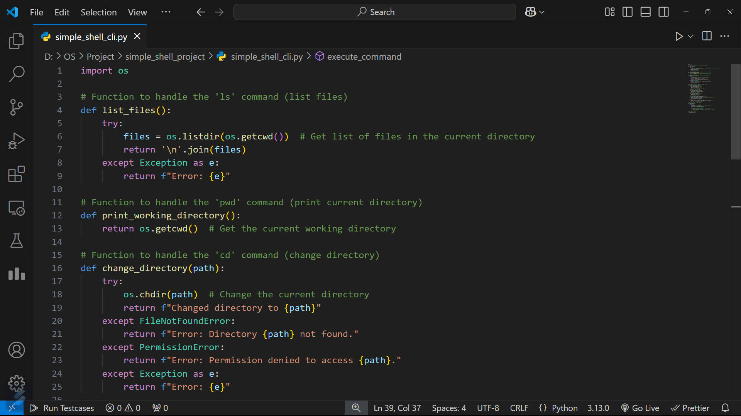

* **Link:** <https://github.com/FaisalHoqueRifat/OS/blob/main/Project/simple_shell_project/simple_shell_cli.py>

1. **Main GUI Implementation:**

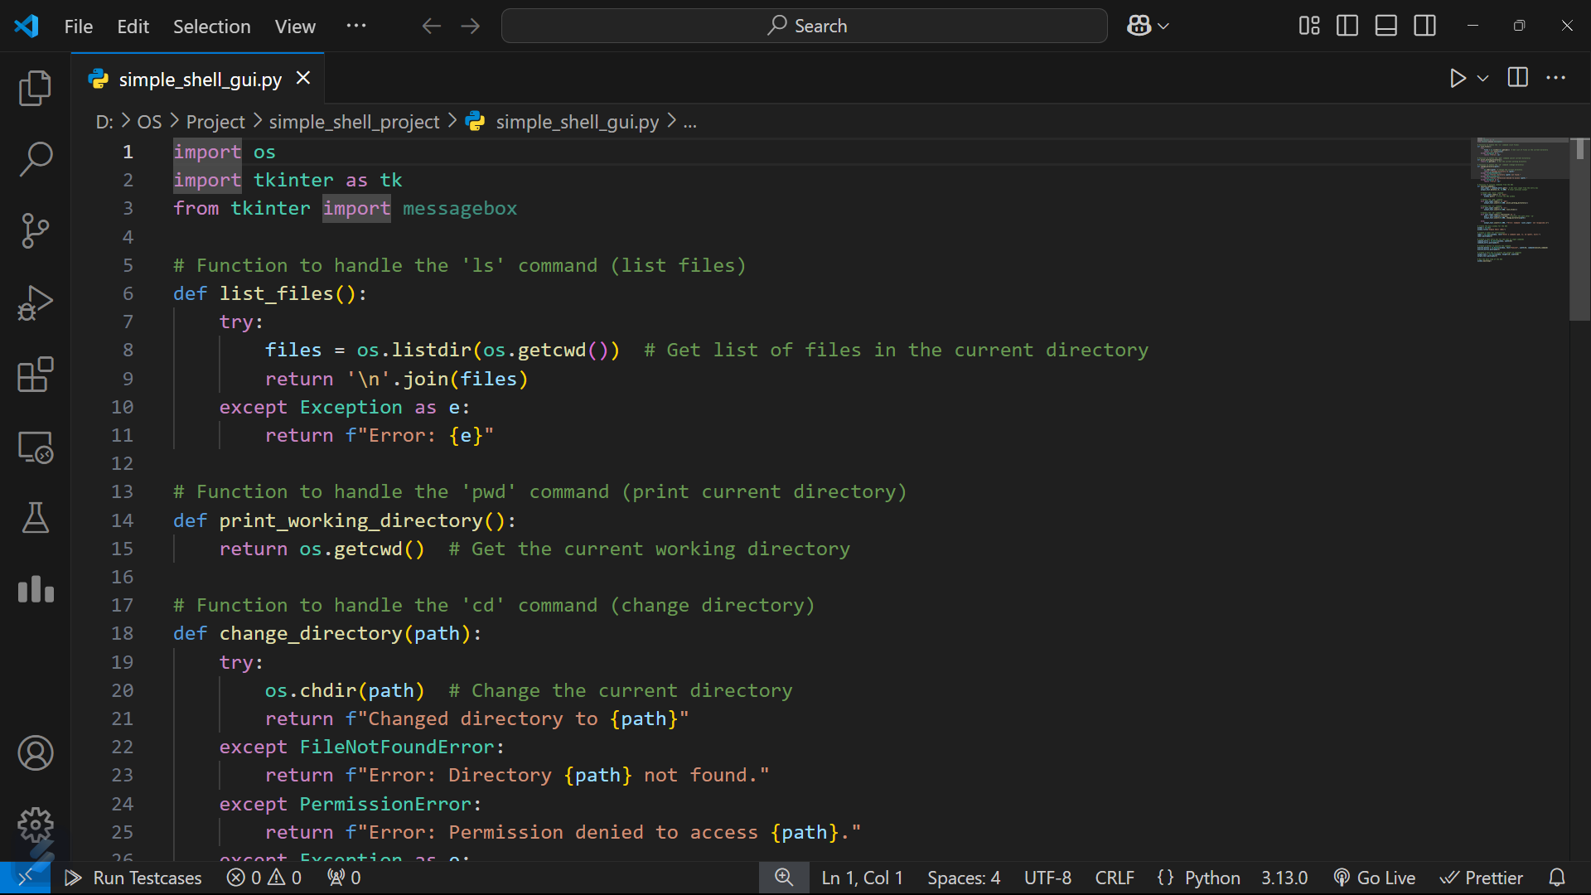

* **Link:** <https://github.com/FaisalHoqueRifat/OS/blob/main/Project/simple_shell_project/simple_shell_gui.py>

**Testing and Results:**

Fig 1.1 CLI Output

Fig 1.2 GUI Output

Fig 1.3 GUI Output

Fig 1.4 GUI Output

***Conclusion:***

This project successfully implemented a simple shell in Python with both CLI and GUI interfaces. The shell demonstrates basic file system navigation and command execution, serving as a foundation for more complex shell functionalities. Python's os and tkinter libraries proved to be effective tools for this purpose.

***Future Work:***

* Adding more commands, such as file manipulation (touch, rm, etc.).
* Improving the GUI for better usability and aesthetics.
* Implementing command history and auto-completion features.

***References:***

* Python os module documentation: [*https://docs.python.org/3/library/os.html*](https://docs.python.org/3/library/os.html)
* Python tkinter module documentation: [*https://docs.python.org/3/library/tkinter.html*](https://docs.python.org/3/library/tkinter.html)